METHODS OF STUDYING HUMAN GENETICS

As we already know that human genetics concerns the scientific study of inherited human variation. Genetic information is passed on from parental generation to the younger generation and it is expressed in the form of phenotypic characteristics. Though genetic is basic approach to understand the inheritable variation in all organisms, the methods of study the same in human is quite different and unique from those of other organisms. It is due to the fact that human’s life cycle is inconveniently long and family sizes are too small to undergo such studies. Moreover, it is difficult or illegal to procure desired matings as can be done in lower organisms. Pedigree and Twin methods which are discussed below are the most important methods that are employed to study human genetics
- Pedigree analysis
Pedigree analysis is the method to identify the mode of inheritance of any trait based on Mendelian inheritance. It can be defined as the diagrammatical representation showing the inheritance pattern of Mendelian traits. In humans, controlled crosses cannot be made, so geneticists must resort to scrutinizing family records in the hope that informative matings have been made that can be used to deduce dominance and distinguish autosomal from X-linked inheritance. The investigator traces the history of some variant phenotype back through the history of the family and draws up a family tree, or pedigree, using the standard symbols given in Figure. Pedigrees show how characteristics are passed from one generation to the next. Just from gathering family histories and creating pedigrees, we can often determine a lot about a genetic condition, like whether it is dominant or recessive. We can also determine whether a condition is caused by a gene on the X chromosome or an autosome. Accurate documentation of the family history is very much essential for pedigree analysis.

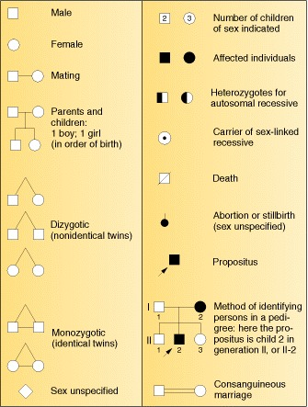
Certain symbols are used in the pedigree studies which are given in figure. The study of the characters is started from proband (sometimes it is also known as propositus and propositia in males and females respectively), and further traced out those who bear common characters among his or her relatives in both preceding and following generations, as many as possible. In the chart, the earliest generation is put at the top followed by the later generations. Different inheritance patterns such as autosomal and sex linked: both dominant and recessive inheritance can be determined by analyzing the pedigree. This has been used to understand the inheritance pattern of any genetic disease or traits.

2. Twin studies

Twin studies have been extensively used in human genetics to estimate the heritability of a particular trait wherein relative contributions of heredity and environment may results into varied phenotypic expression. The method analyzes genetic contribution of a particular trait as against the environmental factors. Perhaps the first, a systematized study on twins was reported in 1924 where geneticist Hermann Siemens compared school transcripts of identical versus fraternal twins to understand the genetic influence on traits. Twins can be monozygotic twin (MZ, identical) or dizygotic twin (DZ, non identical). MZ twin results from the fusion of one sperm and one egg resulting into a single zygote which further divides into two at the embryo stage. While DZ twin results from two different zygotes each formed by the fusion of a sperm and an egg separately. MZ twins are of same sex while DZ twins may be of same sex or different sex. Since MZ twin is developed from a single zygote, it is regarded as having common genetic constitution and DZ as having different genetic constitution like that of siblings.

Methodologically, twin studies is a longitudinal studies where the researchers compare traits of interest in DZ twins rearing together in the same environment or in MZ twins rearing apart in different environment or vice versa. It is based on the assumption that the differential traits developed in MZ twins reared apart would be affect of the environmental factors. Similarly, the alike traits developed in DZ twins reared together would be because of common environmental exposure. One of the important measurements to find out the relative contributions of heredity and environment for quantitative characters is Concordance scores of a trait. It is defined as the percentage of pairs in which both twins express the trait among pairs of twins in whom at least one has the trait (Lewis, 2009) Twins sharing a common phenotype are said to be concordant and as well twins sharing different phenotype are said discordant. Twin studies have been considered as important method to assess nature (genetic) and nurture (environment) approach. Twins both MZ and DZ reared apart shows that the influence of genetic and environmental factors in phenotypic expression. Concordant traits developed in twins reared apart indicate the role of genetic factors.

