Selaginella

SYSTEMATIC POSITION

Division- Lycophyta

Class- Ligulopsida

Order- Selaginellales

Family- Selaginellaceae

Genus- Selaginella

Habit and Habitat of Selaginella:
Selaginella is the only living genus of the order Selaginellales and is commonly known as ‘spike moss’ or ‘small club moss’. It is a large genus comprising of about 700 species distributed all over the world. Abundantly it is found growing in tropical rain forests.
Mostly the species prefer moist and shady places to grow but a few species are also found growing in xerophytic conditions i.e., on dry sandy soil or rocks e.g., S. lepidophylla, S. rupestris etc. A very few species are epiphytes e.g., S. oregena. It is found growing on tree trunks.
A few xerophytic species of Selaginella e.g., S. lepidophylla and S. pilifera show cestipose habit and are sold as curiosities under the name of resurrection plants. They curl and become ball like when dry and again become green and fresh whetin moisture is available. About 70 species have been reported from India.
They are mainly found growing in eastern as well as Western Himalayas and the hills of South India. Some of the common Indian species are S. repanda, S. biformis, S. denticulata, S. monospora, S. semicordata, S. adunca etc. S. kraussiana is cultivated in green house.

External Morphology of Selaginella:
The sporophyte is an evergreen, delicate herb. Its size varies greatly from species to species i.e., from a few cm. to 20 meters. Plants may be erect or prostrate depending upon the sub-genus. In the sub-genus homoeophyllum the plants are erect e.g., S. rupestris, S. spinulosa etc. and in the sub-genus heterophyllum the plants are prostrate e.g., S. kraussiana, S. lepidophylla etc.
The plant body is distinctly differentiated into following structures (Fig. 1 A, C):
(i) Stem.
(ii) Leaves.
(iii) Ligules.
(iv) Rhizophore.
(v) Roots.
(i) Stem:
It is usually profusely branched, delicate and evergreen. The branching is of monopodial type. The growing apex of the stem consists of either meristematic tissue or a single apical cell. In the sub-genus homoeophyllum the stem is erect and somewhat cylindrical and in the sub-genus heterophyllum it is prostrate with stout erect branches and is somewhat dorsiventral.
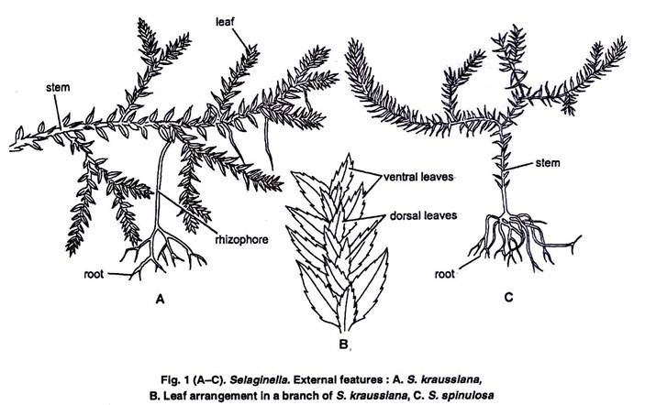
(ii) Leaves:
They are usually small, simple and lanceolate with a pointed apex. Each leaf is provided with a single unbranched midrib. In the sub-genus homoeophyllum all the leaves are of same size and are spirally arranged forming a dense covering.
In the sub-genus heterophyllum the leaves are dimorphic i.e., of two size (small and big) and are arranged in pairs. Small leaves are present on the dorsal side of the stem and bigger ones on the ventral side of the stem (Fig. 1 B). The bigger leaves alternate with bigger ones and smaller leaves alternate with smaller ones.
Usually the leaves near the apical portion of the branch, bear sporangia (micro-or mega) and are called as sporophylls (micro-or mega) respectively. The sporophylls are usually aggregated into a condense structure which is known as strobilus.
(iii) Ligules:
On the adaxial side of the leaf, near the base is present a small membranous out-growth known as ligule. It is embedded at the base of a leaf in a pit like structure known as ligule pit.
It may be tongue shaped (e.g., S. vogelii), fan shaped (e.g., S. martensii), fringed (e.g., S. cuspidata), or lobed (e.g., S. caulescens). It is more than one cell in thickness except at the apex. The structure of the ligule can be differentiated into two parts, glossopodium and the body of the ligule (Fig. 2 A, B).
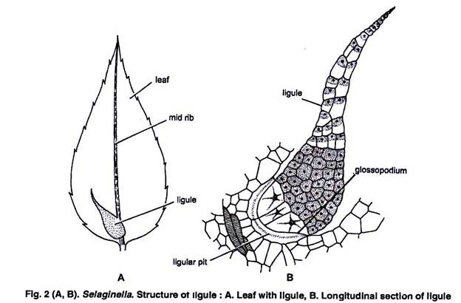
Glossopodium:
It is the basal hemispherical part made up of large thin walled cells. It is surrounded by a glossopodial sheath.
Body of the ligule:
Above the glossopodium is the body of ligule. It is made up of many large and small cells. The function of the ligule is not well known. It may be a water secreting or water absorbing or protective organ. According to Earner (1936) the ligule is perhaps a vestigial organ.
(iv) Rhizophore:
This structure arises from the prostrate axis at the point of dichotomy and elongates downward. It is a colourless, leafless, unbranched and cylindrical structure.
As soon as the free end of rhizophore touches the soil it develops a tuft of adventitious roots at its free end. In few species the rhizophore is present e.g., S. krciussiana while in others it is absent e.g., S. cuspidata. It differs from root in having no root cap and from stem in having no leaves.
The following views regarding the morphological nature of the rhizophore have been proposed:
1. Capless root hypothesis:
According to Harvey Gibson (1902), Uphof (1920), Wochok and Sussex (1974), the rhizophore is a capless root because:
(i) It is positively geotropic.
(ii) It is a leafless structure.
(iii) It is almost similar in anatomy of the root.
(iv) It has a monostelic stele.
2. Leafless shoot hypothesis:
According to Worsdell (1910), Williams (1937), Cusic (1954) etc. The rhizophore is a leaf-less shoot because:
(i) Root cap is absent.
(ii) Root hairs are absent.
(iii) It is exogenous in origin.
(iv) It arises from the angle meristem present at branching.
(v) It can develop into leafy shoot under experimental conditions.
3. Sui-generis hypothesis:
According to Goebel (1905), Bower (1908), the rhizophore is an organ “Suigeneris” i.e., having absolutely no parallel structure anywhere in the plant kingdom. Thus, it is altogether a new structure.
Schoult (1938) regarded rhizophore as specialized stem modified in the direction of root because of the root bearing nature.
(v) Roots:
They originate either from the tips of rhizophores or directly from the stem or from the swollen base of hypocotyl (Fig. 1 A, B). Their origin is endogenous. They are usually dichotomously branched structures. The roots are provided with root caps and root hairs.

Internal Structure of Selaginella:
1. Stem:
A Tranverse section (T.S.) of the stem of Selaginella is somewhat circular in outline and shows the following structures:
(i) Epidermis:
It is the outer most covering layer comprising of a single cell in thickness. The cells of the epidermis are without hairs and stomata. The epidermis is surrounded on all sides by a thick coating of cuticle.
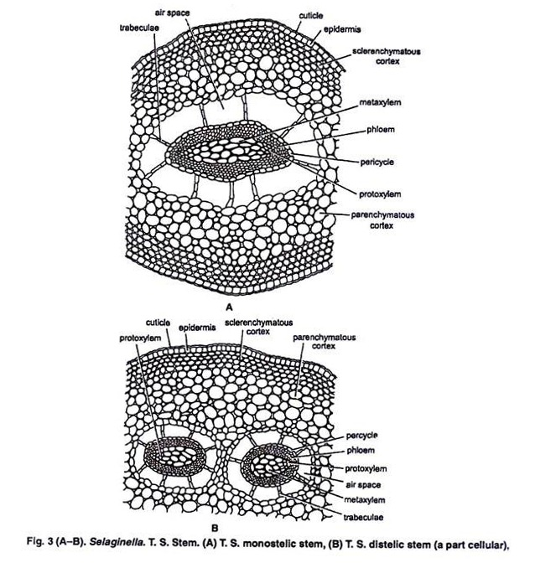
(ii) Cortex:
Inner to the epidermis is present a well-defined zone of cortex. The cortex may or may not be differentiated into inner and outer cortex. In case of S. selaginoides, the whole of the cortex is made up of parenchymatous cells while in S. kraussiana, it is differentiated into sclerenchymatous outer cortex and parenchymatous inner cortex.
The parenchymatous cortex is usually made up of angular cells i.e., without intercellular spaces but in some cases the cells are rounded and provided with a few inter-cellular spaces.
(iii) Stele:
The central portion of the stem is occupied by a well-developed stele. The stele is of protostelic type i.e., xylem is present in the centre and surrounded by phloem on all sides. Phloem, in turn, is surrounded by a single layered pericycle. Pith is absent.
The stele remains suspended in the centre by radially elongated tubular, unicellular structures known as trabeculae. These are formed by the radial elongation of the endodermal cells. Trabeculae are provided with conspicuous casparian strips. In between the trabeculae are present large spaces known as air spaces.
The number of stele is variable in different species of Selaginella. It is 1 (monostelic e.g., S. spinulosa), 2 (distelic e.g., S. kraussiana) or 12-16 (polystelic e.g., S. laevigata). The organization of the stele is also variable in different species. It may be protostele (e.g., S. spinulosa) to siphonostele (e.g., S. laevigata, var. lyalli).
The stele is surrounded by a single layered pericycle made of parenchymatous cells. The xylem is usually monarch (e.g., S. kraussiana), or diarch (e.g., S. oregana) or multiarch (e.g., S. spinulosa).
It is usually exarch but sometimes it may be mesarch (e.g., S. selaginoides). Xylem is usually made of tracheids. Vessels are completely absent. Xylem is surrounded on all sides by phloem which consists of sieve cells and phloem parenchyma. Companion cells are absent in phloem.
2. Root:
A T.S. of the root is somewhat circular in outline (Fig. 4) and shows the following internal structures:
(i) Epidermis:
It is the outermost covering layer and is only one cell in thickness. The cells are large and the unicellular root hairs arise from them.
(ii) Cortex:
Just below the epidermis is present a wide zone of cortex. The cortex may be either wholly made up of thin walled parenchymatous cells or there may be sclerenchymatous outer cortex (hypodermis), 3 to 5 celled in thickness and parenchymatous inner cortex. In mature roots of S. densa the entire cortex may consist of thick walled sclerotic cells. Air spaces have also been reported in the inner cortex (e.g., S. willedenovii). It is traversed by trabeculae.
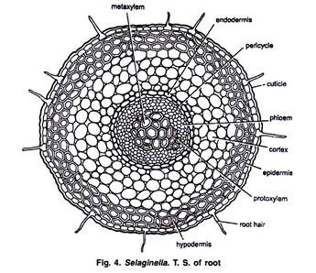
(iii) Endodermis:
It is usually not well defined but in some species as for example, S. densa, it is a distinct structure and only one cell in thickness.
(iv) Pericycle:
Endodermis is followed by one to three layered pricycle. It is made up of parenchymatous cells.
(v) Stele:
It is a typical protostele. The xylem is exarch and monarch i.e., there is only one protoxylem group situated at the periphery. Xylem is surrounded by phloem on all sides. The structure of xylem and phloem elements is similar to that of stem.
3. Rhizophore:
The internal structure of rhizophore is almost similar to that of root. It is also circular in outline.
It shows the following structures (Fig. 5):
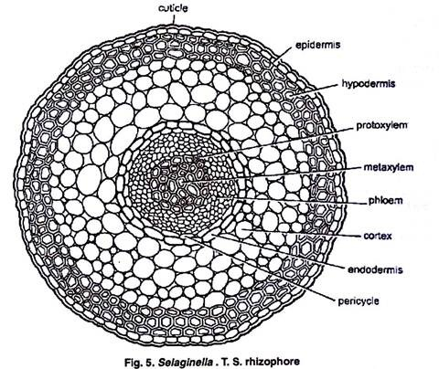
(i) Epidermis:
It is single layered and the outer wall of epidermal cells is covered with a thick cuticle. Root hairs and stomata are absent.
(ii) Cortex:
Inner to the epidermis is present a wide zone of cortex differentiated into outer sclerenchymatous and inner parenchymatous zones.
(iii) Endodermis:
It is inner-most layer of the cortex. It is ill defined single layered structure.
(iv) Pericycle:
Inside the endodermis is present a single layered parenchymatous pericycle.
(v) Stele:
It is typically a protostele. The xylem is surrounded by phloem. Xylem shows distinct protoxylem and metaxylem elements. The position of protoxylem is different in different species. In S. martensii xylem is exarch and monarch. In S. atroviridis the metaxylem is crescentric with a number of protoxylem strands situated on the concave adaxial side. In S. kraussiana, S. poulteri etc. protoxylem is mesarch (centroxylic).
4. Leaf:
A T.S. of the leaf shows epidermis, mesophyll and a single median vascular bundle which has been discussed below in detail:
(i) Epidermis:
It is the outermost surrounding layer and is only one cell in thickness. In most of the species the stomata are present only on the lower epidermis near the midrib. The stomata may be present on both the outer and inner epidermis. The cells of the epidermis are provided with chloroplasts.
(ii) Mesophyll:
It occupies a wide zone between upper and lower epidermis. The mesophyll is usually made up of parenchymatous cells which have conspicuous intercellular spaces. Each mesophyll cell has one (e.g., S. martensii), two (e.g., S. kraussiana), or eight (e.g., willedenovii) chloroplasts.
Each chloroplast has several pyrenoid like bodies similar to order Anthocerotales (Bryophyta). In some species (e.g., S. concinna) the mesophyll is distinguished into upper palisade and lower spongy parenchyma.
(iii) Vascular bundle:
Only one vascular bundle is present in the centre. It is concentric and amphicribal (ectophloic). It is made up of a few xylem tracheids (annular or spiral) surrounded by phloem elements (a few sieve elements). A single layered bundle sheath encircles the phloem on all sides.
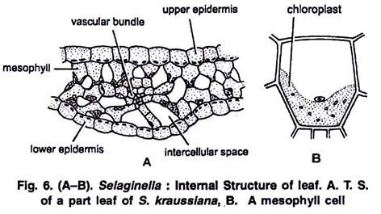

Reproduction in Selaginella:
Selaginella reproduces by two methods: Vegetatively and by formation of spores.
1. Vegetative reproduction:
It takes place by following methods:
(i) Fragmentation:
Under humid conditions in S. rupestris, trailing branches of the stem develop adventitious branches. These branches later disjoin from the parent plant and develop into separate individual plants.
(ii) Tubers:
These appear towards the end of the growing season. The tubers may be aerial, developing at the apical end of aerial branches (e.g., S. chrysocaulos) or subterranean (e.g., S. chrysorrhizos). Under favourable conditions tubers germinate into a new plant (Fig. 7A).
(iii) Resting buds:
These are the compact structures which develop at the apical end of some aerial branches. The leaves in this region are closely arranged and overlap the growing points. These resting buds are capable to pass on the unfavourable conditions. Under favourable conditions these buds give off rhizophore that bear roots at their tips (Fig. 7B).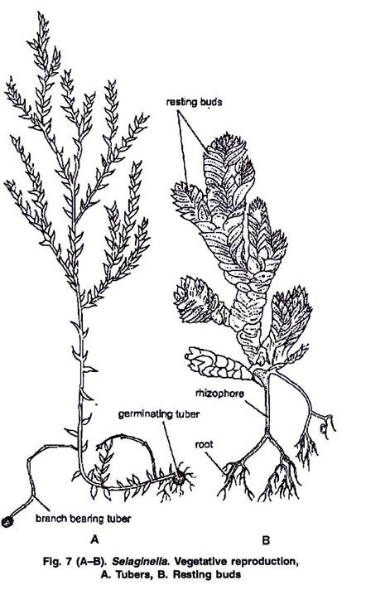
2. Sexual Reproduction:
Spore producing organs:
Selaginella is a sporophytic plant (2x) and reproduces sexually. The plants are heterosporous i.e., produce two different types of spores—megaspores and microspores. These spores are produced in megasporangia and microsporangia, respectively which, in turn, are produced on fertile leaves known as megasporophylls and microsporophylls respectively. Usually both these structures are grouped together to form a compact structure known as strobilus which is usually a terminal structure (Fig. 8 A).
Strobilus:
It is a reproductive structure formed by the aggregation of ligulate sporophylls at the apex of the branches of stem. The length of the strobilus varies from 1/4 inch to 2-3 inches in different species. In some species as for e.g., S cuspidata, S. patula etc. the growth of the stem continues beyond the strobilus and such condition is called selago condition (fertile part is alternated by vegetative parts, Fig. 8 B).
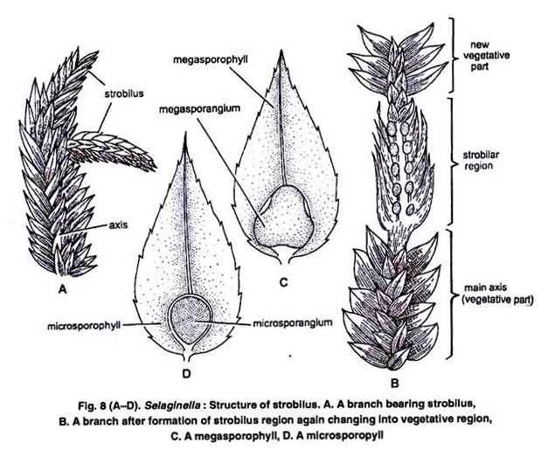
The Longitudinal section (L.S.) of strobilus shows that it is a very simple structure. It consists of a central axis covered with spirally and densely arranged ligulate sporophylls. Each sporophyll adaxially bears a single stalked sporangium in its axis (Fig. 8C, D; 9A).
The positions of the sporangia differ in different species. It may be in axil (axillary) or little upward on in position (cauline). Selaginella produces two types of spores—megaspores and microspores. The dimorphic condition of the spores is known as heterospory.
In between the sporophyll and sporangium is present a small membranous structure known as ligule i.e., the sporophyll is similar to a vegetative leaf. The microsporangium produces large number of microspores whereas megasporangium produces usually 4 megaspores.
Strobili are usually bisporangiate but the arrangement of microsporophylls and megasporophylls differ in different species. In S. inaequalifolia (Fig. 9 A) the microsporophylls are present on one side and megasporophylls on the other side.
In S. rupestris megasporophylls are present on the lower side and microsporophylls on the upper side of the strobilus (Fig 9 B). In case of S. martensii the microsporophylls are mixed irregularly with megasporophylls (Fig. 9 C). In S. kraussiana only one megasporophyll is present while all the rest are microsporophylls (Fig. 9 D). In case of S. gracilis the strobilus is unisporangiate i.e., either it bears microsporophylls or megasporophylls alone.
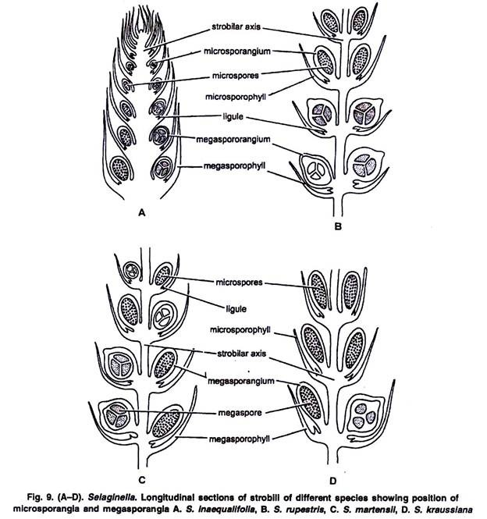
Microsporangium:
Each microsporangium is a stalked, globular or elongated structure (Fig. 8 D). Its colour varies from red, yellow to brown in different species. The wall is 2 layered thick which is followed by a conspicuous tapetum (Fig. 10 F). In the young sporangium inside the wall is present a mass of sporogenous cells which in due course of development separate into microspore mother cells and later on by meiotic divisions produce numerous haploid tetrads of microspores.
The microspores at maturity separate from each other. At maturity the tapetal cells as well as the inner wall of the microsporangium disorganizes i.e., wall of the sporangium is usually one layered at maturity. Microspores are smaller in size.
Megasporangium:
Each megasporangium is also a stalked but lobed structure and somewhat bigger than the microsporangium. Its colour varies from whitish yellow to red. Its wall is also 2 layered thick and followed by a single layered tapetum (Fig. 10G). In the young sporangium inside the wall is present a mass of sporogenous cells which in due course of development separate into megaspore mother cells. All the megaspore mother cells accept one degenerate.
The remaining one later on by meiotic division produces only 4 haploid megaspores. Sometimes less than 4 megaspores are produced inside each megasporangium. As for example, S. rupestris produces only one megaspore per megasporangium. At maturity the tapetal cells usually along with inner wall of the sporangium disorganise. Megaspores are larger in size than microspores (Fig. 10 G).
The sporangia usually dehisce by a vertical slit formed in apical region of the sporangia and the spores are disseminated in the air.
Development of sporangium and formation of spores:
As the position of sporangium is either cauline or foliar, the initials are either situated on the axis or on the leaf respectively. The development of sporangium and formation of spores (micro-and mega) is similar upto the formation of spore mother cells and is as follows:
The development is of eusporangiate type i.e., it takes place with the help of a row of initials which are known as sporangial initials e.g., S. kraussiaiia (in some cases from a single sporangial initial cell e.g., S. spinulosa). These cells are superficial in position (Fig. 10 A).
These cells divide periclinally forming outer jacket initials and inner archesporial initials (Fig. 10 B). The jacket initials by further periclinal and anticlinal divisions form the jacket which is 2 celled thick (Fig 10 E). The archesporial initials divide in all directions forming a group of cells known as sporogenous tissue.
The cells of the outer most layer of sporogenous tissue divides periclinally forming a single layered tapetum just inner to wall of sporangium. It is a nourishing layer (Fig 10 C-E). Tissue at the base of sporangium divides to form the sporangial stalk. The cell of sporogenous tissue in case of microsporangium finally gives rise to microspore mother cells and in case of megasporangium gives rise to megaspore mother cells.
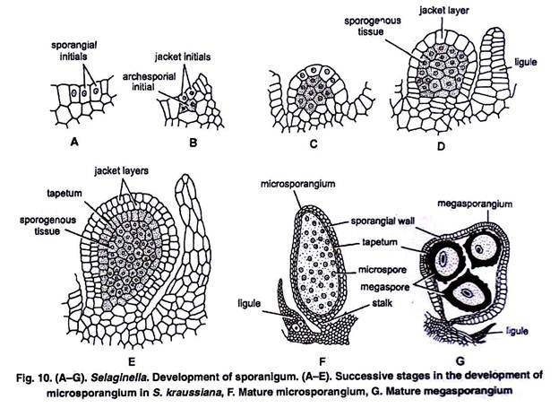
In microsporangium all the microspore mother cells are functional and each one divides reductionally forming a tetrad of 4 haploid microspores, as a result of which a large number of tetrads of microspores are formed inside microsporangium. Later on these microspores separate from each other.
The mature microsporangium dehisces by a vertical slit in the apical region. By the drying of unsplitted portion, the spores are forced out and then they are dispersed away by wind.
In megasporangium all the megaspore mother cells degenerate except one which divides reductionally forming a tetrad (Fig. 11 D) of 4 haploid megaspores. The dehiscence of megasporangium is similar to that of microsporangium.
Gametophytic Generation:
The development of male and female gametophytes (prothalli) takes place from the haploid microspores and megaspores respectively i.e., microspores and megaspores are the unit of male and female gemetophytes, respectively.
Spore:
The microspores are small, 0 015 to 0 05 millimeter in diameter, spherical or round in shape and double layered structures. The outer wall is thick and known as exospore (exine). While inner wall is thin and is called endospore (intine, Fig 11 A-C).
The megaspores are much larger than microspores, 1.5 to 5 millimeter in diameter, tetrahedral in shape and show triradiate ridge. The megaspore has three wall layers namely exospore, mesospore and endospore (Fig. 11 D, E). The microspores on germination give rise to male prothalli and megaspores to the female prothalli.
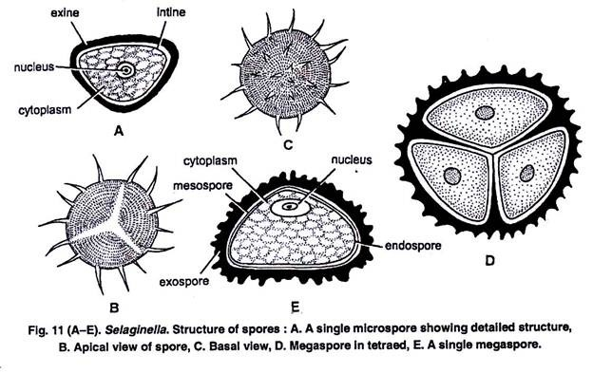
Development of male gametophyte:
The microspore is the initial stage in the development of male gametophyte. The development of the microgametophyte is in situ or precocious i.e., it starts within the microsporangium. Generally a 13-celled microgametophyte is formed before the microsporangium dehisces.
Each microspore is a unicellular, uninucleate, rounded or spherical, haploid structure with outer spiny thick exosporium and inner thin endosporium. The first division is in such a way that 2 unequal cells are formed„ smaller prothallial cell and a larger antheridial cell (Fig. 13 A).
The prothallial cell does not divide further and takes no part in further development of male gametophyte. The antheridial cell divides to form a group of 12 cells. The antheridial cell divides vertically (2-2) to the prothallial cell to form the two primary cells of the antheridium (Fig. 13B). At this stage the young gametophyte consists of 3 cells (2+1 cell, Figs. 12 A, B; 13 B).
The wall which separates the two primary cells is called first primordial wall. Two primary cells thus formed divide transversely (3-3 Figs. 12 C). This division is at right angle to the first and can be seen only if we cut a vertical section of the spores. This stage of gametophyte consists 5 cells (2 + 2+1 cells).
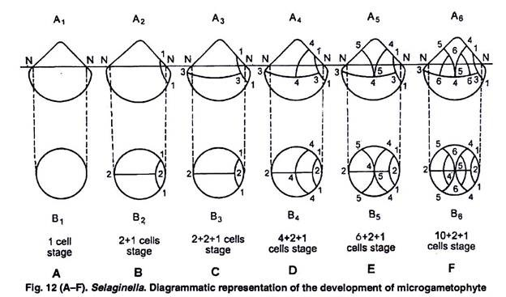
Out of these four cells formed by the division of primary cells, the basal cells divide no further and become the cells of the jacket layer of the antheridium. Upper two cells divide further by curving or arching wall (4-4, Fig. 12 D). In this way 6 cells are formed and microgametophyte has seven cells at this stage (4+ 2+1 cells).
Out of the four cells formed by the last division, two bigger cells divide again by curved wall (5-5, Fig. 12 E) and thus a 9 celled microgametophyte is formed (6 + 2+1 cells, 8 antheridial cells and one prothallial cell). These antheridial cells are arranged in such a manner that four cells are present in the middle and two cells are present on either side i.e., above and below.
The middle four cells divide by periclinal walls (6-6, Fig. 12 F; 13 D) to form 4 primary androgonial cells and 8 jacket cells. The gametophyte now consist 13 cells (1 prothallial cell + 4 androgonial cells + 8 jacket cells). In S. kraussiana the gametophyte is shed at this stage. Further development takes place after shedding.
At this stage the spores are liberated and their exosporium ruptures. Primary androgonial cells divide and redivide to form 128 or 256 androcytes or antherozoid mother cells.
Each antherozoid mother cell finally metamorphosis into a single antherozoid (Fig. 13 F, G) which is a spirally coiled, uninucleate and biflagellate structure. The two flagella are unequal in size. The antherozoids are liberated by the rupturing of endosporium and swim in water till they reach the neek of archegonium.
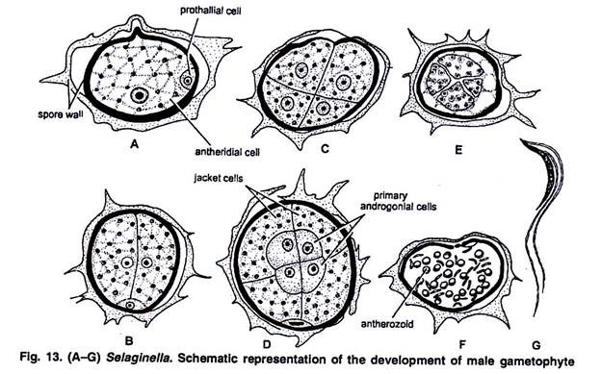
Development of female gametophyte:
The megaspore is the initial stage in the development of female gametophyte. The development of female gametophyte starts while the megaspore is still inside megasporangium. The megaspores are liberated from the megasporangium either at the time of first archegonium formation or just after fertilization.
First of all the exospore or outer wall grows faster than the mesospore which result in the formation of space between exospore and mesospore. The whole structure increases in size as a result of which a big central vacuole appears (Fig. 14 A).
Now nucleus divides by free nuclear divisions, forming a large number of nuclei. First the nuclei are equally distributed in the cytoplasm but later on more nuclei collect in the apical region.
At this stage wall formation starts from the apical region downwardly thus forming an upper cellular region known as female prothallus and a lower non-cellular region known as storage region. The wall of the lower cells becomes thick forming a diaphragm (Fig. 14 B-E). Later on the vacuole also disappears as the cytoplasm increases in amount.
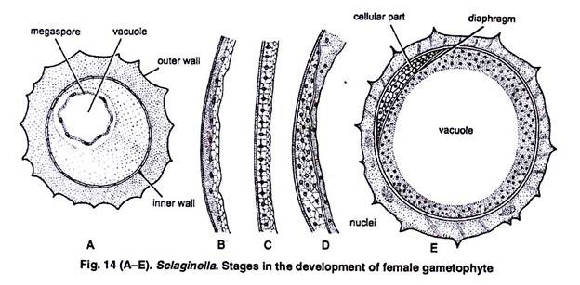
This may be absent in a few species e.g., S. martensii. At this stage usually the female gametophyte is liberated from the gametangium. If it falls on suitable substratum, it germinates. The exine and mesine ruptures. The cellular tissue protrudes out and a few rhizoids develop which fixes the gametophyte to the substratum and absorbs water (Fig. 15).
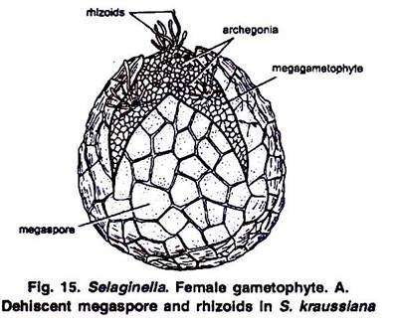
Development of archegonium:
A few cells near the apex of female prothallus behave as archegonial initials which by further divisions, give rise to archegonia (Fig. 16H). Each archegonium develops from a single superficial cell of the female prothallus situated near the apical region and is termed as archegonial intitial (Fig. 16 A).
It divides transversely forming an upper primary cover cell and a lower central cell (Fig. 16 B). The primary cover cell, by two vertical divisions at right angle to each other, forms 4 cells which by a transverse division forms a neck of 2 tiers of 4 cells each (Fig. 16 C, D).
The central cell again divides to form an upper primary neck canal cell and a lower primary venter cell (Fig. 16 D). The former forms a single neck canal cell while the latter divides to form a ventral canal cell and egg (Fig. 16 E).
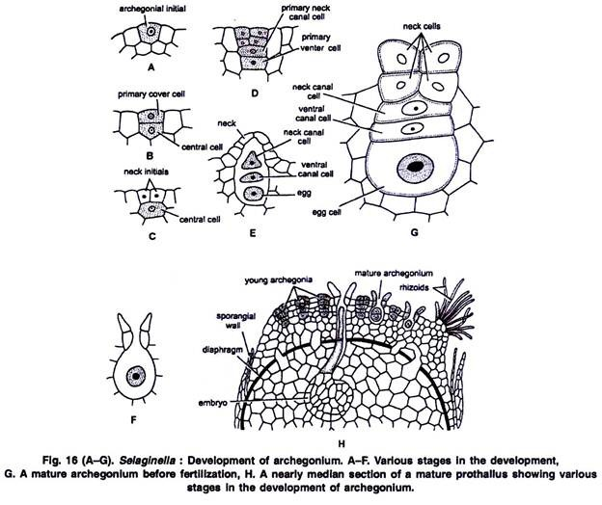
Structure of Mature Archegonium:
The archegonium is a short flask shaped structure embedded in female gametophytic tissue (Fig. 16 H). Only the upper tier of neck cells projects out. Each archegonium consists of a short neck of 2 tiers of 4 cells each and a broad venter. The four cells of the upper tier of neck function as cover cells.
The neck encloses a single neck canal cell and the venter consists of a ventral canal cell and an egg (Fig. 16 G). There is no definite wall of venter. At maturity the neck canal cell and the ventral canal cell disorganize and absorb water which creates a pressure to separate apart the cover cells (Fig. 16 F) through which the antherozoids enter the archegonium and reach the egg.
Fertilization:
Water is necessary to carry out the process of fertilization. The swimming antherozoids reach the egg through the neck of archegonium and the nucleus of antherozoid fuses with the egg nucleus thus forming a zygotic nucleus. The fertilized egg secretes a wall around it forming a diploid structure known as zygote or oospore (2x). Thus the gametophytic generation ends and the initial stage of sporophytic generation is formed.
In some species e.g. S. intermedia the egg develops into embryo without fertilization. This phenomenon is known as parthenogenesis.
Embryo Development (Young Sporophyte):
Development of embryo:
Oospore is the initial stage of sporophytic generation. During development of the embryo, the oospore first divides by a transverse division into an upper suspensor initial (epibasal) and a lower embryo initial (hypobasal) (Fig. 17 A, B).
The suspensor initial further divides in all directions forming a multicellular suspensor which thrusts the developing embryo deep into the female gametophytic tissue to absorb food for further development of embryo. The embryo initial divides by 2 vertical divisions at right angle to each other thus forming 4 cells (quandrant. Fig. 17 C).
One of these 4 cells divides by an oblique wall forming a shoot initial (Fig 17 D). Now the cells except the shoot initial divide sporophyte transversly forming 2 tiers of 4 cells each. Later on by further divisions it forms a multicellular structure which gets differentiated into foot, rhizophore, stem and cotyledons (Fig. 17 E-J).
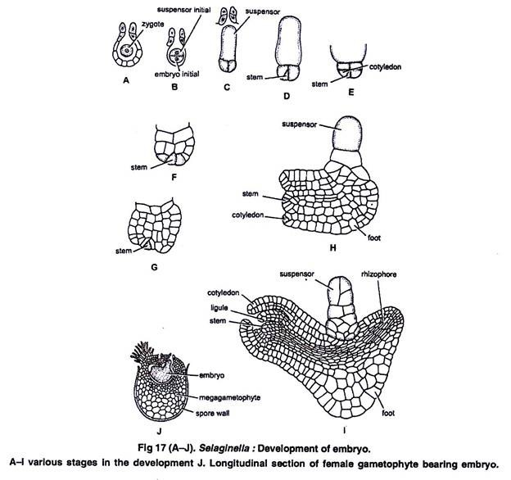
In some species of Selaginella (e.g., S. apus and S. rupestris the megagametophytes arenever shed from the megasporangium and remain on the strobilus. The oospore completes its development within the megasporangium and the young embryo grows into a seedling, develop primary root and then falls on the ground (Fig. 18).
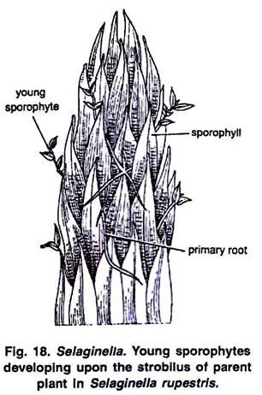

Life Cycle Patterns of Selaginella:
Selaginella is a sporophytic plant (2n) and produces two different types of spores i.e., microspores and megaspores. In other words we may call it as heterosporous plant. These spores on germination produce male and female gametophytes (n) respectively which in turn developing upon the strobilus of parent produce antherozoids and egg in antheridia and archegonia respectively.
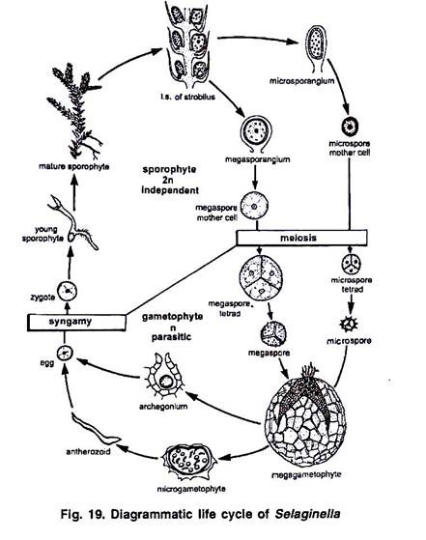
These reproductive structures after fertilization produces zygote (2n) which again on germination gives rise to a sporophytic plant (2n). In this way the sporophytic and gametophytic generations alternate with each other although the sporophytic phase is dominant over gametophytic phase (Fig. 19).

