6 th SEMESTER (MAJOR)
PAPER 603: REGIONAL GEOGRAPHY OF NORTH EAST INDIA WITH SPECIAL FOCUS ON ASSAM
UNIT 2: ASSAM
By -Rashmi Sarkar
Locational Significance
Introduction
Assam, state of India. It is located in the northeastern part of the country and is bounded to the north by the kingdom of Bhutan and the state of Arunachal Pradesh, to the east by the states of Nagaland and Manipur, to the south by the states of Mizoram and Tripura, and to the west by Bangladesh and the states of Meghalaya and West Bengal. The name Assam is derived from the word asama, meaning “peerless” in the now extinct Ahom language. The neighbouring states of Arunachal Pradesh, Nagaland, Mizoram, and Meghalaya were once part of Assam. The capital, formerly Shillong (now the capital of Meghalaya), was shifted to Dispur, a suburb of Guwahati, in 1972. The total geographical area of Assam is 78,438 square km and Population. 31,169,272 (2011).
Geography
A significant geographical aspect of Assam is that it contains three of six physiographic divisions of India – The Northern Himalayas (Eastern Hills), The Northern Plains (Brahmaputra plain) and Deccan Plateau (Karbi Anglong). As the Brahmaputra flows in Assam the climate here is cold and there is rainfall most of the month. Geomorphic studies conclude that the Brahmaputra, the life-line of Assam, is an antecedent river older than the Himalayas.

LOCATIONAL SIGNIFICANCE OF ASSAM
- Assam is located in the central part of North East India between 24°3'N latitude and 27°58' N latitude and 89°5' E longitude and 96°1' E longitude. Assam shares border with Arunachal Pradesh in the east, West Bengal, Meghalaya, Bangladesh in the west; Arunachal Pradesh, Bhutan in the north and Nagaland, Manipur, Mizoram, Tripura in the south.
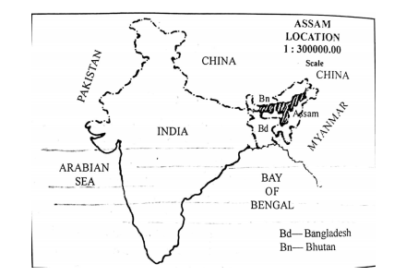
Fig: Location of Assam
- Geographically, Assam is situated in one of the most important strategic locations. It is the Gateway to the Far East. It was particularly through the gates of Assam that the Mongoloids had come to India from their homeland in Indo-China. Assam can thus be rightly termed as an “anthropological museum” owing to fact that it is inhabited by people belonging to different races and having different culture, language and religious beliefs.
- Assam is bestowed with vast natural resources.
- Assam controls the entry point to the North east region through the Siliguri corridor. Loss of Assam would mean loss of the entire land mass in the North East along with its rich natural resources.
- Assam tea is famous all over the world. North East India produces more than 2/3 of the total tea production of India and Assam alone produces more than 20% of the world’s tea. Tea industry has a turnover nearly of Rupees 3000 crores.
- Besides there is abundance of other mineral resources like coal, gas, limestone, mica and so on in the state.
- Apart from that, the hydro power potential of the region is enormous in the tunes of 60000 MW. NER is called the powerhouse of India.
- With the emergence of China as an economic and military powerhouse the global geopolitical perspective has shifted and South East Asia got special importance. Assam is India’s gate way to the South East Asia, which has now become a very important from this geopolitical point of view. Re-opening of the Stillwell will accelerate trade with Burma and the South East Asian countries.
- The NER become the nerve centre of the Act east Policy. India seeks to integrate SE Asia and NER with a network of highways, railways, pipelines and transmission lines. As such India has concluded a number of bilateral and multilateral projects. Assam is the key to the success for India’s Act East Policy
- Thus, the geographical location of Assam plays a very important role for the development of Assam as well as India.
****************************

