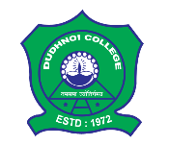 | DUDHNOI COLLEGE  Only College in the Goalpara District with  B⁺⁺ NAAC Accreditation  Dudhnoi, Goalpara, Assam-783124
Email: dudhnoicollege@gmail.com |  | Website: www.dudhnoicollege.ac.in
Date of Admission of Higher Secondary first year (Arts and Science):
HS First year Science (All) |  |  | 01/07/2022
HS First year Arts (Up to 53% marks) |  |  | 01/07/2022
HS First year Arts |  |  | 02/07/2022 and 04/07/2022
Students are requested to bring online application forms of Darpan, Dudhnoi College online portal and all other relevant documents (Photocopy and Original)
Dr. Lalit Ch. Rabha
Principal, Dudhnoi College

