BORO SIR-DOC-1
6th sem,paper-602
MEANING AND DIFINITION OF SOCIAL GEOGRAPHY

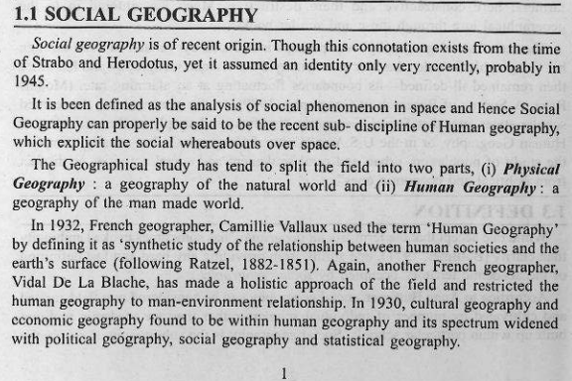

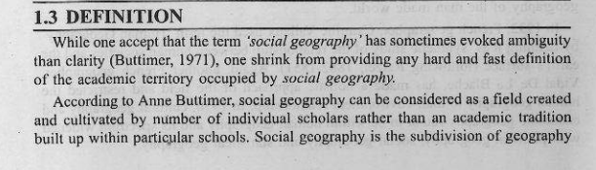
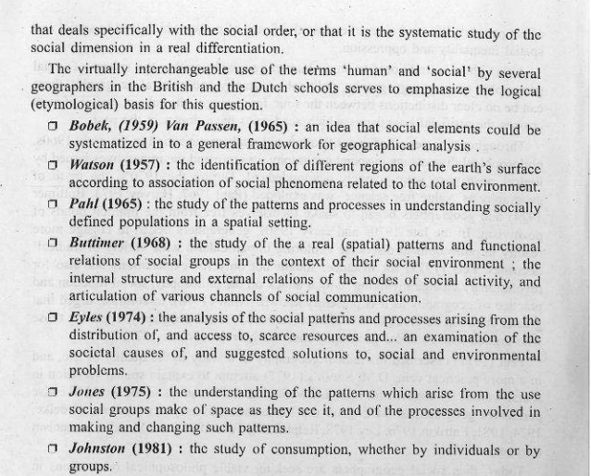

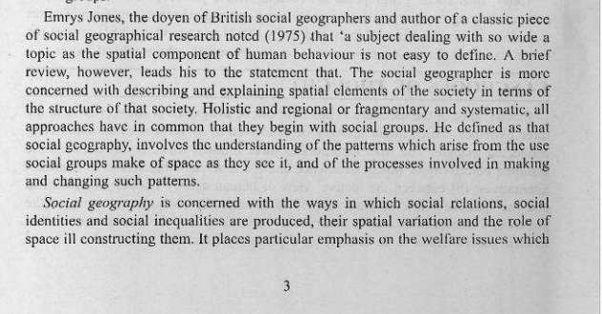
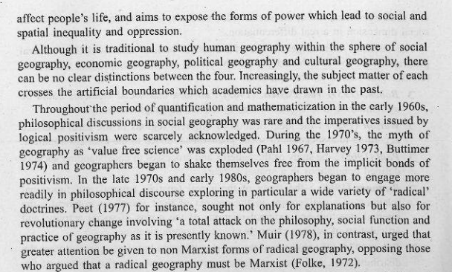
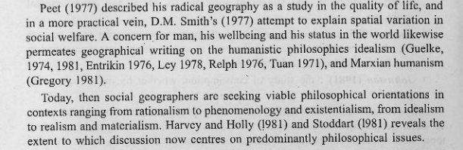

-----------------------------------------------------------------------------

Scope of Social Geography

The scope of social geography we can study with following heads

1. Primary ways
Social Geography is primarily concerned with the ways in which social relations, identities and inequalities are created.
How these social creations vary over space and the role of space in their construction is the principle distinction between sociology and social geography.
- Social Interaction and relations
According to PANOPIO, 1997, Social interaction refers to the mutual inter stimulation and response between two or more persons and groups through symbols, language, gestures and expression of ideas.
Social interaction is the foundation of society. Without interaction there would be no group life.
Social interaction has different form of interaction:
1. Between individual to individual
2. Between Individual to Groups
3. Between groups to groups 4. Between individual and culture

- Formation of Social Groups

Unit of interacting personalities with interdependence of roles and statuses existing between and among themselves • Collection of people where members interact on a regular basis, guide by structure and agreements, defined by roles and responsibilities.
4. Characteristics of Social groups
Group members interact on a fairly regular basis through communication.
Members should develop a structure where each member assumes a specific status and adopts a particular role.
Certain orderly procedures and values are agreed upon. • The members of the group feel a sense of identity.
5. Types of Social Groups
Below are the types of Social Groups:
1. Primary Group (Families, Play groups)
2. Secondary Group (industrial workers, Faculty Staff)
3. According Self-identification
4. According to purpose
5. According to geographic location

6. Community and Society
The Primary difference between a community and Society is that a community is limited to a specific geographic location, but a society can be made up of people who live in different places.Another difference is that a society is made up of direct and indirect social connections between people, but a community is made up of individuals who are more closely connected. For example, people who live in town represent a community, whereas everyone who lives in the state the town is located in makes up a society.
Several communities can be located within a society but each society is separate from another.
• Societies often include more diversity, with people from different backgrounds, social classes and races.
People in communities most often share similar characteristics.
---------------------------------------------------------------
TUMALOKE COPY KORI LOWA CLASS MOI PISOT KORIM
OK
GO HEAD

