BORO SIR-DOC-2
PAPER-602

APPROACHES TO THE STUDY OF SOCIAL GEOGRAPHY
Important Approaches to the study of social geography are:

1.
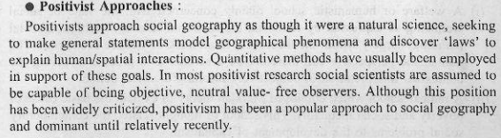

2.
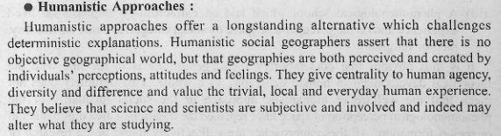
3.
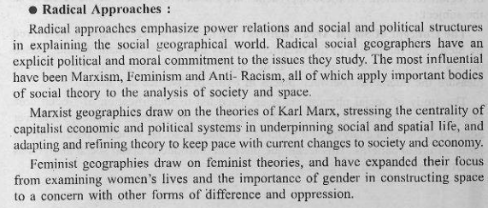
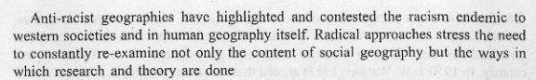
4.
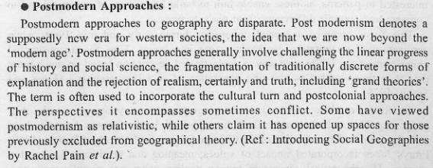

STUDY MATERIAL NO 2 COPY IT

