6th Semester
Paper 605
Practical on Advance techniques in Geography
Unit 2: Computer Application GIS, GPS
Prepared by : Rashmi Sarkar
Department of Geography

- Geographical data entry (Spatial and non spatial), tabulation and charting bar graph, pie graph

Ans: Procedure of Geographical data entry (Spatial and Non spatial): Data input is the procedure of encoding data into a computer-readable form and writing the data to the GIS data base. There are two types of data to be entered in a GIS - spatial (geographic location of features) and non-spatial (descriptive or numeric information about features).

There are three types of data entry:
  - Manual (via typing on keyboard or importing text files);
  - Digitizing;
  - Scanning;
Manual data entry can bring into GIS either collected or measured data. These data exist as simple text files or binary files. Text files should have at least two columns with X and Y coordinates. These columns allow geo referencing of the file i.e. association of it with specific geographic coordinate system. Binary files are usually a product of the software package associated with measuring device (for example files from Global Positioning System data collection). They also have X and Y data, associated with description of the collected features, but in encoded format that could be read by special software.
Digitizing is a process of entering digital codes of analyzed data into computer. Digitizing can be manual (using digitizing tablet) or automatic (using scanner). The difference between two methods is that digitizing tablet allows to do geo referencing during the digitizing process, while scanning require geo referencing later, after digital file (usually TIFF, GIF or JPEG image) has been created. Another difference between methods is speed and accuracy of the data processing. Apparent slowness of the work on digitizing tablet compensates often for the amount of editing after scanning process. At the same time good scanning allows automatic layer separation (for example, separation of red-colored roads from brown-colored contour lines), while digitizing of the map on a tablet requires manual creation of separate themes. In this case the condition of the original hardcopy is very important. Since human operator can use more cognitive tools and knowledge than the software support for scanning device, digitizer can handle better the hardcopy in a poor condition . Special kind of scanned data is remote sensing image, taken either by satellite camera, digital camera Or video camera.
Non-spatial data (also called attribute or characteristic data) is that information which is independent of all geometric considerations. For example, a person's height, mass, and age are non-spatial data because they are independent of the person's location.
Tabulation of Data:
The raw data is collected in an unclassified form. It is difficult to understand it and to draw a conclusion from it. This data is presented in a systematic and arranged form. Tabulation is a systematic & logical presentation of numeric data in rows and columns to facilitate comparison and statistical analysis. It facilitates comparison by bringing related information close to each other and helps in further statistical analysis and interpretation. In other words, the method of placing organized data into a tabular form is called as tabulation. It may be complex, double or simple depending upon the nature of categorization.
5 Major Objectives Of Tabulation:
(1) To Simplify the Complex Data It reduces the bulk of information, i.e. raw data in a simplified and meaningful form so that it could be easily by a common man in less time.
(2) To Bring Out Essential Features of the Data It brings out the chief/main characteristics of data. It presents facts clearly and precisely without textual explanation.
(3) To Facilitate Comparison Presentation of data in row & column is helpful in simultaneous detailed comparison on the basis of several parameters.
(4) To Facilitate Statistical Analysis Tables serve as the best source of organised data for further statistical analysis.The task of computing average, dispersion, correlation, etc. becomes easier if data is presented in the form of a table.
(5) Saving of Space A table presents facts in a better way than the textual form. It saves space without sacrificing the quality and quantity of data.
Bar Graph:
A bar chart or bar graph is a chart or graph that presents categorical data with rectangular bars with heights or lengths proportional to the values that they represent. The bars can be plotted vertically or horizontally. A vertical bar chart is sometimes called a column chart.
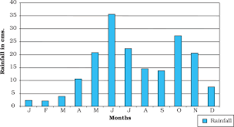
Pie Graph:
A pie chart is a type of graph that represents the data in the circular graph. The slices of pie show the relative size of the data. It is a type of pictorial representation of data. A pie chart requires a list of categorical variables and the numerical variables. Here, the term “pie” represents the whole, and the “slices” represent the parts of the whole.

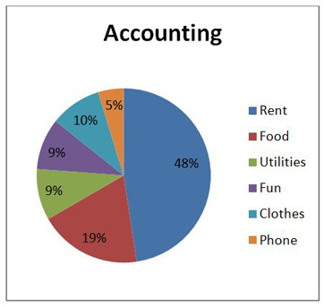
2. Mapping of various geographic features from the image (Point, Line and Area), (Procedure of Mapping)

Ans:

Point Data
Point data is most commonly used to represent non adjacent features and to represent discrete data points. Points have zero dimensions, therefore you can measure neither length or area with this dataset. Examples would be schools, points of interest, and in the example below, bridge and culvert locations. Point features are also used to represent abstract points. For instance, point locations could represent city locations or place names.

Line Data
Line (or arc) data is used to represent linear features. Common examples would be rivers, trails, and streets. Line features only have one dimension and therefore can only be used to measure length. Line features have a starting and ending point. Common examples would be road centerlines and hydrology. Symbology most commonly used to distinguish arc features from one another are line types (solid lines versus dashed lines) and combinations using colors and line thicknesses. In the example below roads are distinguished from the stream network by designating the roads as a solid black line and the hydrology a dashed blue line.

Polygon Data
Polygons are used to represent areas such as the boundary of a city (on a large scale map), lake, or forest. Polygon features are two dimensional and therefore can be used to measure the area and perimeter of a geographic feature.
Polygon features are most commonly distinguished using either a thematic mapping symbology (color schemes), patterns, or in the case of numeric gradation, a color gradation scheme could be used.
Both line and point feature data represent polygon data at a much smaller scale. They help reduce clutter by simplifying data locations.
As the features are zoomed in to, the point location of a school is more realistically represented by a series of building footprints showing the physical location of the campus.
Line features of a street centerline file only represent the physical location of the street. If a higher degree of spatial resolution is needed, a street curb width file would be used to show the width of the road as well as any features such as medians and right-of-ways (or sidewalks).
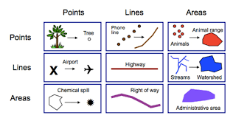

Raster Data
Raster data (also known as grid data) represents the fourth type of feature: surfaces. Raster data is cell-based and this data category also includes aerial and satellite imagery. There are two types of raster data: continuous and discrete. An example of discrete raster data is population density. Continuous data examples are temperature and elevation measurements. There are also three types of raster datasets: thematic data, spectral data, and pictures (imagery).
In its simplest form, a raster consists of a matrix of cells (or pixels) organized into rows and columns (or a grid) where each cell contains a value representing information, such as temperature. Rasters are digital aerial photographs, imagery from satellites, digital pictures, or even scanned maps

General characteristics of raster data
In raster datasets, each cell (which is also known as a pixel) has a value. The cell values represent the phenomenon portrayed by the raster dataset such as a category, magnitude, height, or spectral value. The category could be a land-use class such as grassland, forest, or road. A magnitude might represent gravity, noise pollution, or percent rainfall. Height (distance) could represent surface elevation above mean sea level, which can be used to derive slope, aspect, and watershed properties. Spectral values are used in satellite imagery and aerial photography to represent light reflectance and color.
Cell values can be either positive or negative, integer, or floating point. Integer values are best used to represent categorical (discrete) data and floating-point values to represent continuous surfaces. For additional information on discrete and continuous data, see Discrete and continuous data. Cells can also have a NoData value to represent the absence of data. For information on NoData, see NoData in raster datasets.




