6 th SEMESTER (MAJOR)
PAPER 604: PRINCIPLES AND APPLICATION OF REMOTE SENSING, GIS AND GPS
UNIT 2: GEOGRAPHICAL INFORMATION SYSTEM
Prepared by: Rashmi Sarkar

Topic: Nature and Types of Geographic data (Sptial and Non Spatial)

Introduction:
Data which are geographically referenced describe both the location and characteristics of spatial features on the Earth’s surface. For example, to describe a tourist place, we need to refer to its location (i.e. where it is?) and its characteristics (i.e. name, classification, number of tourists visiting that location, etc.). Therefore, geoinformatics involves two components of geographic data. First component is spatial data, which relate to the geometry of spatial features, and the second component is non-spatial or attributes data, which provide information about spatial features.
Nature of Data:
‘Data’ or datum in the singular is derived from Latin word, which means ‘having been’ or that which is ‘given’. A similar concept is contained in the French translation of data as ‘donnée’, which also means ‘given’. In other words, data are those things on which understanding and explanations are based. Data contains information which is represented in the format of digit, letter and symbol that is used to describe status, behavior and the outcome of geographical objects. Let us put it more simply. Data are those things on which understanding, explanations and inferences are based.
The three terms are used interchangeably referring to data having a spatial component.
1.‘geographic’ refers to the Earth’s surface and near surface hence geographic data would refer to any data related to Earth’s surface and near surface.
2. ‘Geospatial’ specifically refers to location relative to the Earth’s hence, ‘geospatial data’ refers to any data related to any features and phenomenon related to Earth and has location as one of its attributes. Further, it does not necessarily refer to the surface of the Earth but also above (as in weather) or below (as in ground water) the Earth.
3. The term ‘spatial’ is a broad term which refers not only to the space of Earth’s surface but to any space. Hence, ‘spatial data’ may refer to any data related to any planet, cosmos and even of human body also.
Thus, ‘geospatial data’ is a subset of ‘spatial data’. The terms ‘geospatial data’ and ‘geographic data’ are often used interchangeably. However, ‘geospatial data’ is considered more precise in many contexts than ‘geographic data’ because it is also used in ways that do not necessarily involve a graphic representation of the information.
Data are the basis of information and in general represent the measure of the external world. Only an expert system (human or machine i.e., computer) is able to convert data into information by reading it according to established rules. Thematic maps and topographical maps are the examples of geospatial information that are derived from satellite images or aerial photographs, which represent the geospatial data.
Types of data
Data can be broadly classified into primary and secondary data. Primary data refers to data collected by the first hand fieldwork and survey. Secondary data are those which are found in published sources, such as official statistics and maps or derived from primary data, or are gathered by some external agency. Similarly, geospatial data can also be categorised into primary and secondary geospatial data.
• Primary data can be collected from the sources, such as from ground survey (including GPS survey), aerial photography and satellite remote sensing, etc.
• Secondary data can be acquired by converting existing maps or other documents into a suitable digital form. Data derived after some processing of primary geospatial data are also the examples of secondary geospatial data. The geospatial data has two components based on location and its characteristics. The location (also known as geometry or shape) represents spatial component, whereas the characteristics represent the attributes or nonspatial component. Hence, the two basic data types commonly used in geoinformatics tools are:
- Spatial Data
- Non-spatial Data

Spatial Data
To qualify as spatial data, a data should have following characteristics: i) it should have reference to locations on Earth’s surface ii) it should have an explicit relationship between geometric and attribute aspects of the information represented iii) it should be organized in a particular theme, and iv) it should have features, such as area, line or point. Spatial data records the relationship among and about geographically distinguishable features. Examples include the location of a rain gauge, area submerged under flood, the route a delivery truck takes, the extent of damage from a forest fire or a tourist place. Like other kinds of data, spatial data can be categorised into primary and secondary spatial data. Representation of real world features as discrete objects is done through two modes of data representation, which embody the linkage between the real world domain of geographic data and computer representation of these features. Thus, the spatial data fall into two basic categories: vector and raster data.
• Vector data represents discrete features, such as customer locations, streets, parcels, land usage and data summarised by area.
• Raster data represents continuous numeric values, such as elevation, and continuous categories, such as vegetation types, and water.
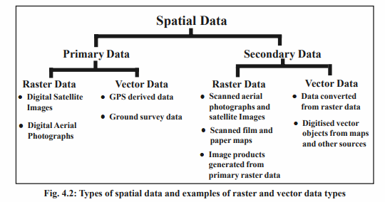
- Vector Data
In the vector data, spatial locations of features are defined on the basis of coordinate pairs. In this data format, real world features are represented in the form of:
• lines (arc or line data)
• points (point or node data), and
• polygons (closed boundary encompassing area).
Points (or nodes) are the fundamental building block of spatial data. They refer to a specific place, generally in a two-dimensional space. Points are used to record the locations of objects, such as tourist place or overhead bridge. Vectors are lines between the points, and are generally stored as an ordered series of two or more nodes. Linear features, such as pipelines, roads and rivers are usually represented in as vector data. Polygon is a closed figure made from several vector lines, where the first and last node in the series is the same point. Polygons are used to represent features having areal extent, such as lakes, political boundaries, soil type, etc., as shown in Fig. 4.3. The figure depicts how the real world is seen as vector data.
- Raster Data
In raster data type, real world features are represented as grids. Raster data uses a fixed grid dimension and record information about each grid. One or more features are associated with each grid cell. One set of cell and associated value is known as a layer, as shown in Fig. 4.3. Raster data, which often comes from remote sensing also include thematic maps or scanned maps, as shown in Fig. 4.2. Digital satellite images are one of the commonly used forms of raster data. If you are familiar with digital photography, you will be able to recognise the raster graphics pixel as the smallest individual grid unit which is a building block of an image.
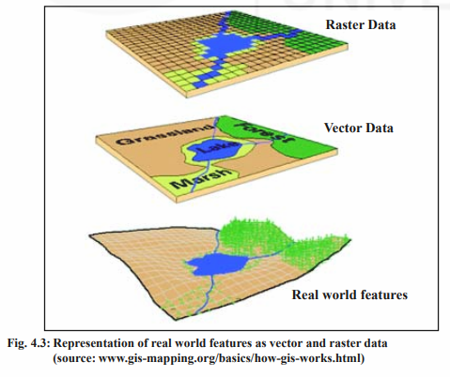
Non-spatial/Attribute Data
Non-spatial data generally records information about the objects represented as the spatial data, such as material used to construct a building, the type of rain gauge used to measure rainfall intensity, or land use. Non-spatial data also known as attribute (tabular) data are the descriptive data that are linked to spatial data as shown in Fig. 4.4. Attribute data are collected and compiled for specific project work, like districts in the states, census tracts, name of cities, and so on, and often comes packaged with map data.




