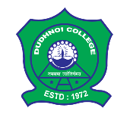 | DUDHNOI COLLEGE  Only College in the Goalpara District with  B⁺⁺ NAAC Accreditation  Dudhnoi, Goalpara, Assam-783124
Email: dudhnoicollege@gmail.com |  | Website: www.dudhnoicollege.ac.in
Dudhnoi College invites application from eligible candidates
for admission into the
B.A., B. Sc., and B. Com. First Semester Classes
for the Session 2022-2023
How to apply:
- The candidates must apply to Dudhnoi College through the college online portal (https://www.dudhnoicollege.ac.in ) by filling up all necessary details.
- Please note that: Mode of application is strictly through online only. No application forms will be available in the College Office.
- The last date of Application: 05/07/2022
Date of Admission:
B. Com |  | 06/07/2022
B. Sc. |  | 06/07/2022
B. A. |  | 07/07/2022 and 08/07/2022
Dr. Lalit Ch. Rabha
Principal, Dudhnoi College

