55 Days Free Training Program on Muga Silkworm Cultivation
Organised by CAREER COUNSELLING CELL in collaboration with IQAC, Dudhnoi College

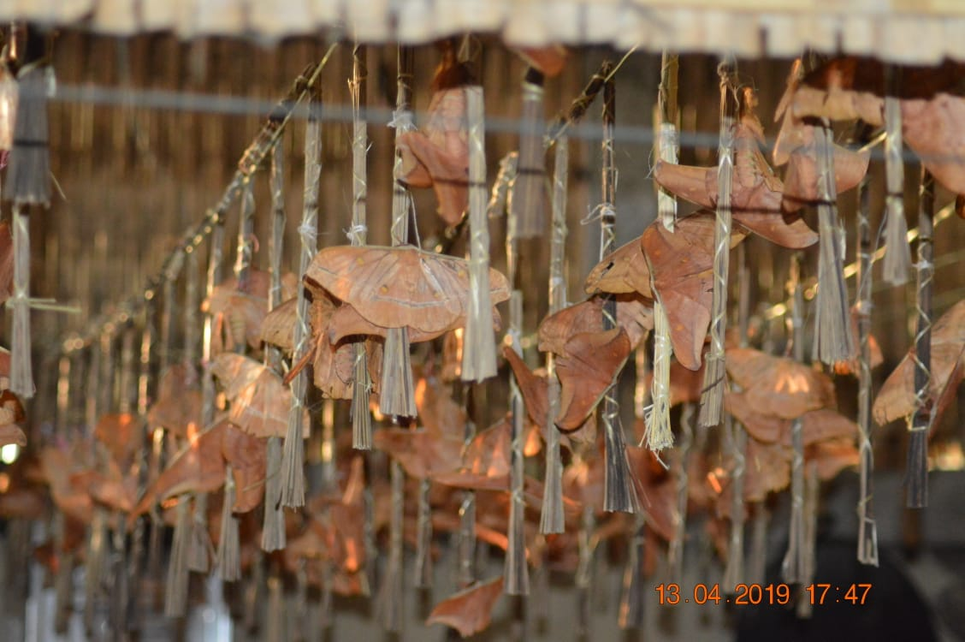

Objective of the Training Program
- To provide thorough knowledge of Muga silkworm cultivation and silk production.
- To promote sustainable agricultural practices and boost local economies.
- To empower participants with the skills needed to start their own Muga silk production ventures.
- To contribute to the preservation and promotion of the traditional Muga silk industry.

About the Training Program
The 55 Days Free Training Program on Muga Silkworm Cultivation is designed to educate and empower individuals interested in the unique and lucrative field of Muga silk production. This comprehensive program covers all aspects of Muga silkworm cultivation, from the basics to advanced techniques, ensuring participants gain hands-on experience and in-depth knowledge.
Last Date of Registration: 16th May
Program Scheduled: 18th May to 11th July, 2024
Who Can Attend This Program
- Anyone passionate about sustainable and traditional silk production.
- We primarily prefer students.
How to Join the Training Program
- Contact the Co-ordinator of the program.
- Collect the Registration Form and submit with required documents.
Whom to Contact
Dr. Mridul Dutta
9864409947
mridulduttamc@gmail.com
Training Duration and Mode
- Duration: 55 days
- Mode: The training program will be conducted in offline mode. This ensures that participants can learn the theoretical aspects remotely while gaining practical experience on the field.
Post-Training Certification
Upon successful completion of the training program, participants will receive a certificate of completion. This certification will attest to their knowledge and skills in Muga silkworm cultivation, enhancing their credibility and opportunities in the industry.

